Exercise: Android Overview and Basic
Document Number: |  | Issue Number:  Date:

TABLE OF CONTENTS
1 Exercise 1: Create a very simple Android application 2
1.1 Description 2
1.2 Create new Android application. 2
2 Exercise 2: Android lifecycle 10
2.1 Description 10
2.2 Watch the change of Android in lifecycle 11
2.3 Create new Activity so we can test all cases. 13
3 Create first GUI application with TextView,EditView and Button. 17
3.1 Description 17
3.2 Create new project 17
3.3 Add TextView,EditView and Button 17
3.4 Write inner code 19
3.5 Run test 19

Exercise 1: Create a very simple Android application

Description
The purpose of this exercise is let student understand how to work with GUI designer. At the end of this exercise they can create a very simple application which will inform a sentence after user click a button.

Create new Android application.
In Eclipse, go to File -> New - >Others
Choose Android -> Android Application Project.
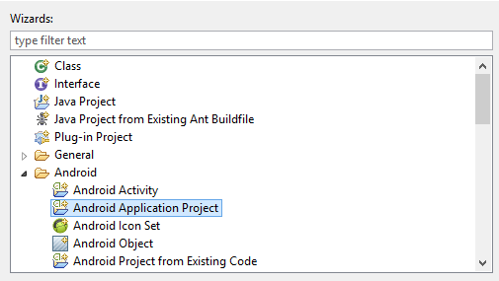
Name Application Name: MySimpleApp and press Next.
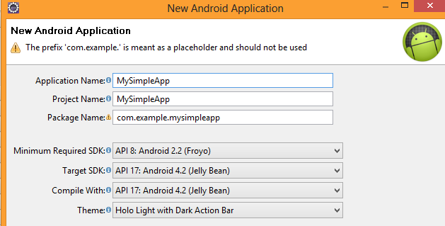
Continue to press Next until Finish is highlighted.
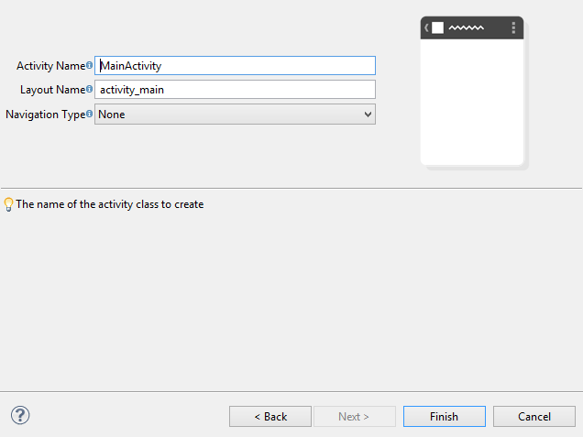
Click Finish.
In GUI designer, double click to let it expands full screen.
Drag the Button icon to designer screen.
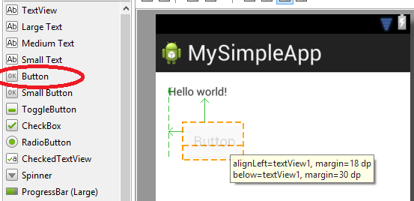
Try to drag Button to the end of the screen and then stretch it to fulfil the screen.
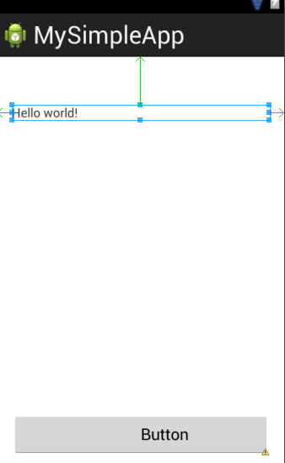
Do the same to label “Hello world”.
Click on Button. Look at the right in Properties tab.
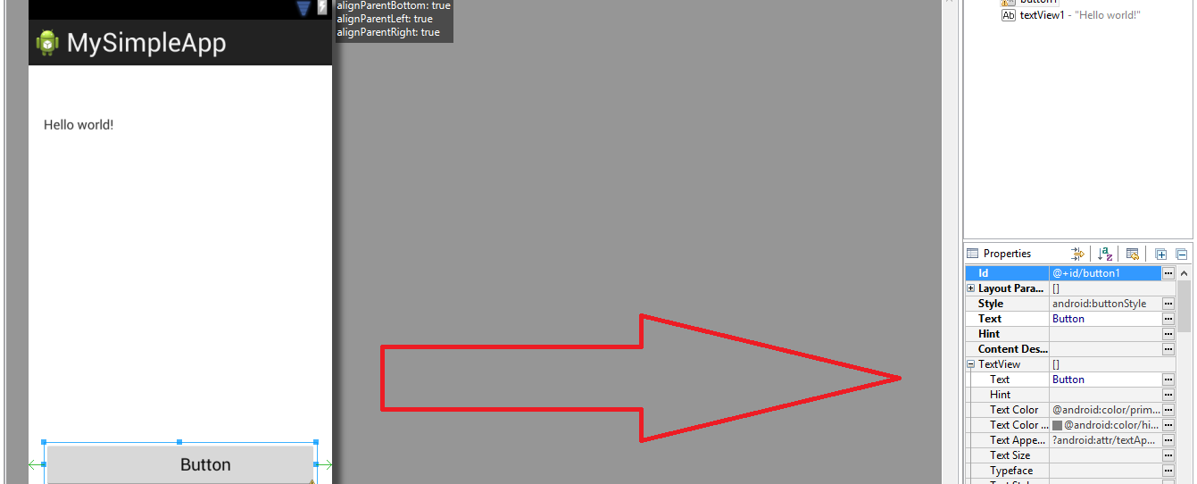
Click on […] at the right of “Id”. Fill “clickMe”
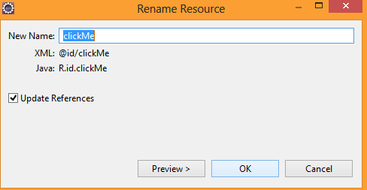
Press OK.
Click on […] at the right of Text. Press New String.
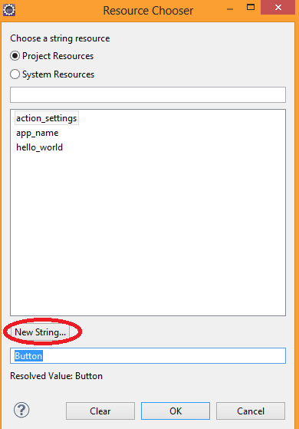

Type:
- String: Click Me
- New R String: click_me_string
and then press OK.
Choose click_me_string and press OK.
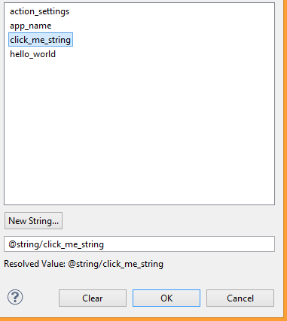
Do the samething for the label. Change it Id to titleLabel.
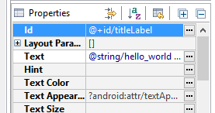
Press Ctrl + S to save the editing file.
Click double on tab activity_main.xml to back to File Explorer screen.
In Package Explorer, go to gen -> com.example.mysimpleapp ->R.java
Take a look at public static final class id
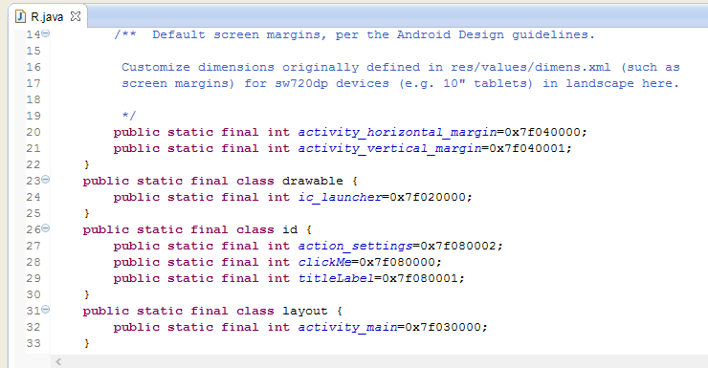
Continue to find string class.
This R.java is generated by Android ADT and it contains all needed constants which represent controls / String resources we will need to access in future.
Go back to MySimpleApp. Go to res -> layout -> activity_main.xml
Click on “Click Me”. Go to Properties Tab -> under View, find OnClick
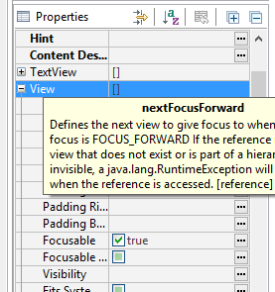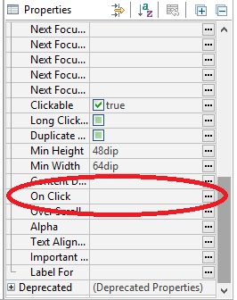
Type “clickMe”.
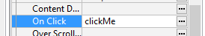
Press Ctrl + S to save the file.

Take a look at over of GUI designer. Click on MainActivity
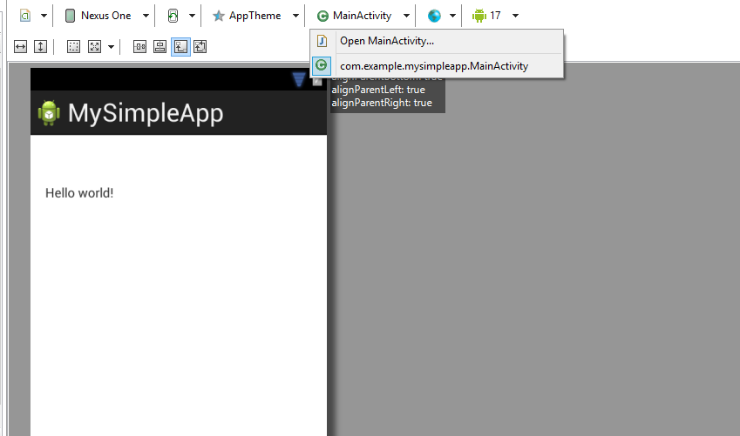
Open MainActivity…
Create new function clickMe(View view)
public class MainActivity extends Activity {

@Override
protected void onCreate(Bundle savedInstanceState) {
super.onCreate(savedInstanceState);
setContentView(R.layout.activity_main);
}

@Override
public boolean onCreateOptionsMenu(Menu menu) {
// Inflate the menu; this adds items to the action bar if it is present.
getMenuInflater().inflate(R.menu.main, menu);
return true;
}

public void clickMe(View view) {

}
}
Press Ctrl + Shift + O in order to import lacking libraries.
Fill in content of clickMe function.
public void clickMe(View view) {
TextView title = (TextView)findViewById(R.id.titleLabel);
title.setText("Hello Android world !");
}

Press Ctrl + S to save the file.
Right click on MySimpleApp, choose Run -> Android Application.
Choose Android4.2 , press OK.
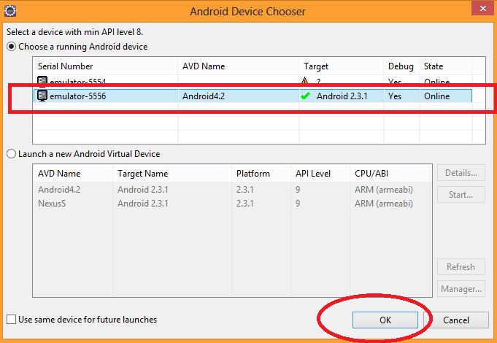
Switch on virtual machine. Press on Click Me button.
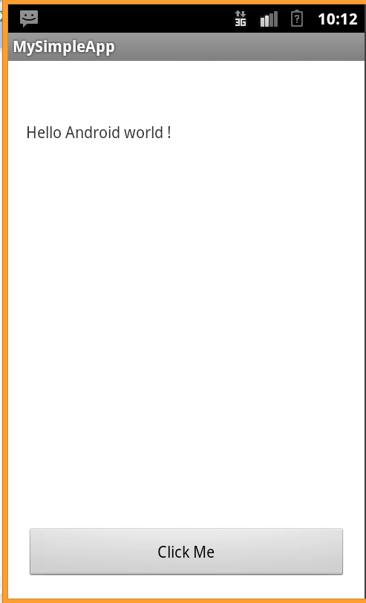
Congratulation! You have created your first working simple Android application.

Exercise 2: Android lifecycle

Description
The purpose of this exercise is let student watch the changes in lifecycle of an Activity, so they can have an overview about the internal working of Android application.

Watch the change of Android in lifecycle
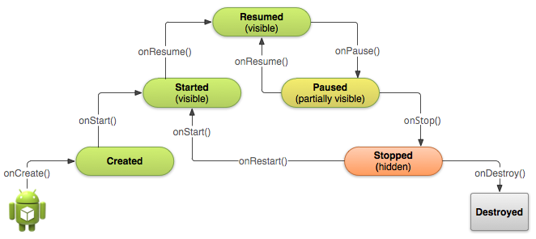
An Activity should go to those lifecycle steps:
Created -> Started -> Resumed -> Paused -> Stopped -> Destroyed
To watch those steps, we should start by creating new project.
Create new Android Application Project and name it: MyLifecycleApp.
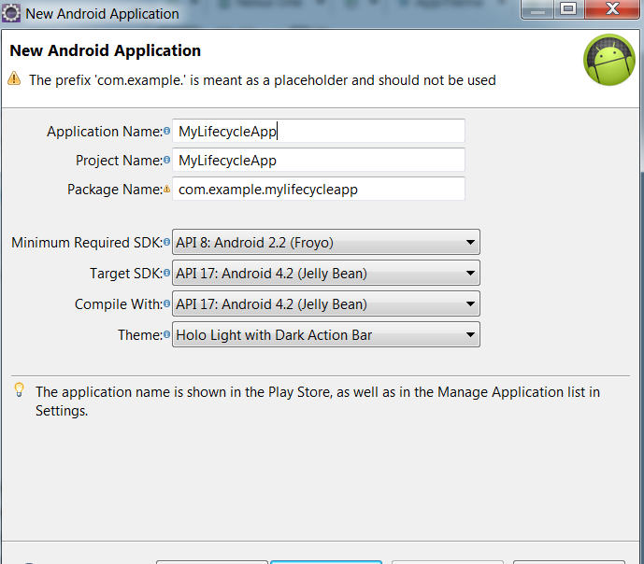
Click Next until Finish can clickable. Press Finish.
Go to activity_main.xml , drag a button on it. Name it as follow:
Id: switch_button
Text: Switch ( create a String resource name switch_button).
On Click: switchToNext
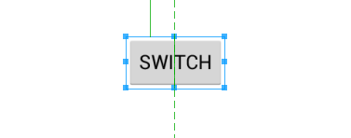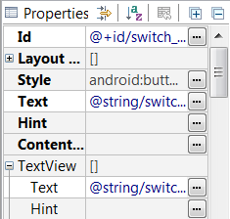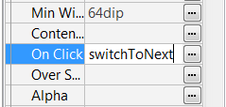
Press Ctrl + S to save it. Switch to MainActivity
Press Alt + Shift + S -> Override/Implement methods
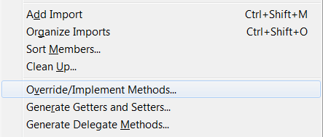
Choose those methods:
- onDestroy
- onPause
- onResume
- onRestart
- onStart
- onStop

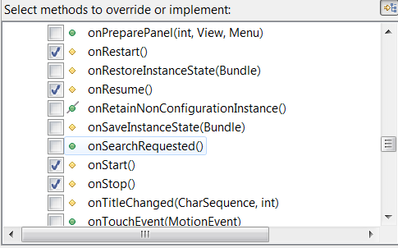
Choose InsertionPoint: Last Member. Press OK.
Source changes as follow:
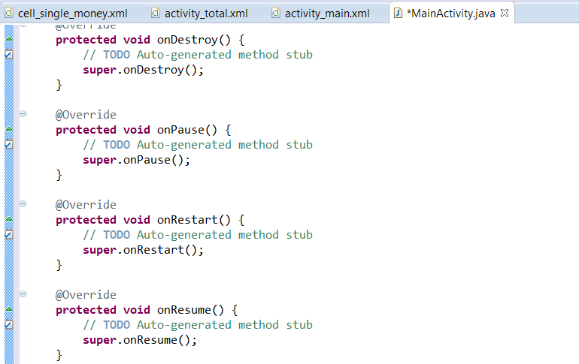
In onDestroy, type:
@Override
protected void onDestroy() {
Toast.makeText(this,"onDestroy", Toast.LENGTH_SHORT).show();
super.onDestroy();
}
Ctrl + S to save it.
Type similar commands for other functions, but replace the corresponding text such as:
onResume() {
Toast.makeText(this,"onResume", Toast.LENGTH_SHORT).show();
super.onResume(); }
After you complete all, save it by Ctrl +S or Ctrl + Shift + S (Save All).

Create new Activity so we can test all cases.
Create new Activity by rightclick on MyLifecycleApp ->New -> Others ->Android Activity.
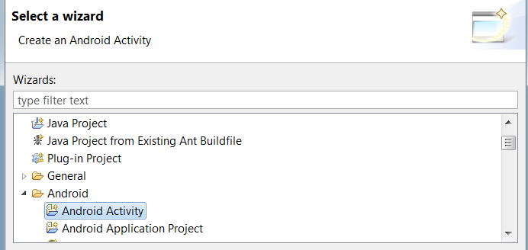
Click Next -> Click Next.
Type name is : NextActivity. Click Finish. You go to activity_next.
Go to MainActivity. Create new function switchToNext like this:
public void switchToNext(View view) {
Intent intent = new Intent(this,NextActivity.class);
startActivity(intent);
}

The purpose of these lines is:
- Create an Intent to inform Android that we intent to move to NextActivity. The content of Intent constructors is reserved to Android so it can now which activity we will move. In this case, it is NextActivity
- Do this by using startActivity(intent).
Press Ctrl + S to save.
Start Android4.2 virtual machine by using AVD manager.
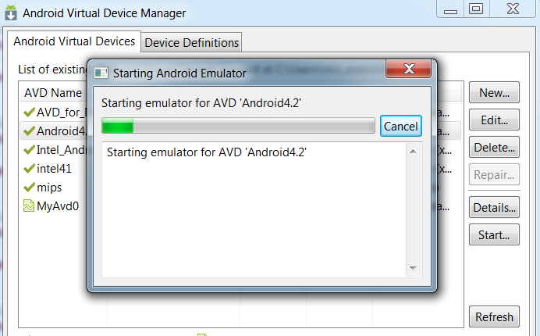
Run it by right-click on MyLifecycleApp, Run -> Android application.
Choose Android4.2 virtual machine.
Press OK and wait.
Open LogCat ( by Windows -> Show View -> Other -> LogCat )
Switch to Android4.2 virtual machine.
We will see onStart and then onResume followed.
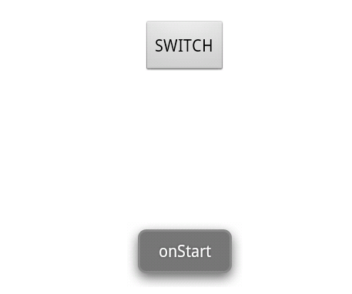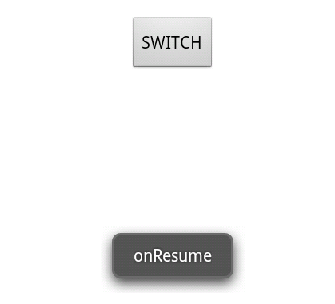
It means that Activity has run on those step: Created -> Started -> Resumed.
Explain: First, Activity will create onCreate to go to Create state. After that, it called onStart to inform Android that it will start this Activity. When in Start state, Activity is visible. But then it call onResume to put Activity to Resume state, which is stays on the screen and waiting for input from screen. It can be imagined in this way:
Activity 1
Activity 2
Activity 1
Activity 2

Activity 1

Activity 1 start and resume ( visible)
Activity 2 start and resume ( visible).
Activity 1 paused and not visible
Activity 1 resume and become visible.
|Activity 2 destroyed ( not visible).

Resume is the state to show that Activity becomes visible on screen and waiting for input. That’s why we need 2 steps: Started and then Resumed.
Press Switch. It shows onPause and onStop.
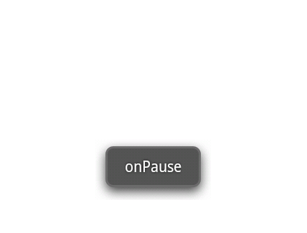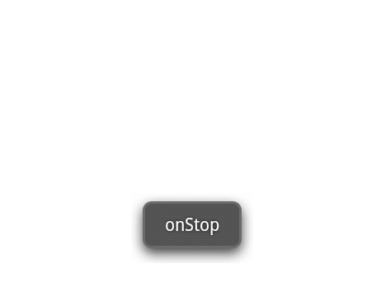
Activity goes to Paused state, but when it is not visible at all, Android decided to collect it by calling onStop to put that activity to Stopped state (hidden). Please take note that Stopped is different to Destroyed ( Android destroy the activity completely).
Press Back on keyboard.
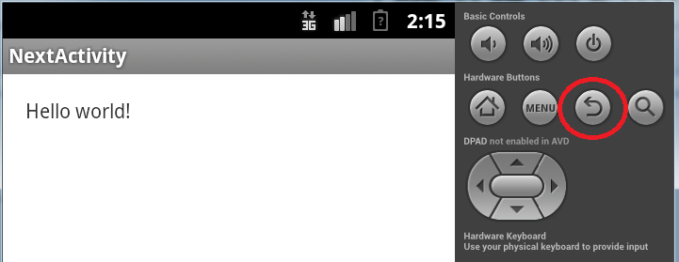
The screen show onRestart and then onStart and the onResume.

Because activity is hidden totally, so Android need to restart it by call onRestart(). This onRestart will call onStart -> onResume to make Activity go back to Resume state.
Press Back  again.
Application exits. It show onPause -> onStop -> onDestroy. Because the application thread runs to the end, Android decided destroying activity completely.
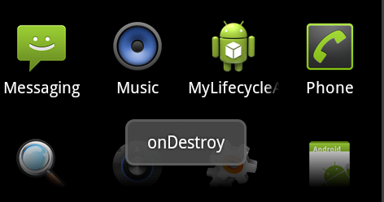
Congratulation! You have completed the second exercise.

Exercise 3: Create first GUI application with TextView,EditView and Button.

Description
Purpose of this exercise is let student familiar with common controls in Android. At the end of this exercise, student can complete a sample application let them calculate the exchange rate between USD & VND.

Create new project
Create new Android Application project, name it:MyFirstGuiApp
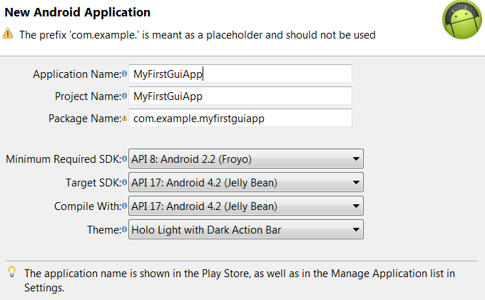
Click Next until Finish is visible.Click Finish.
Choose HelloWorld textview and delete it.

Add TextView,EditView and Button
Drag 3 MediumText to GUI:

Edit as:

Control | ID | String | R.id.String
textView1 | usd_label | USD: | usd_label_string
textView2 | exchange_rate_label | Exchange Rate: | ex_rate_string
textView3 | vnd_label | VND: | vnd_label_string

Drag 3 number TextField to screen. These TextField just allows user to enter number only.
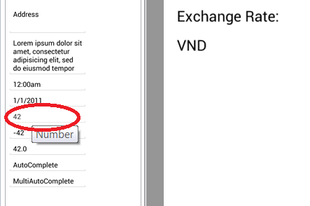
Edit as follow:
Control | ID | String | R.id.String
editView1 | usd_text
editView2 | exchange_rate_text
editView3 | vnd_text
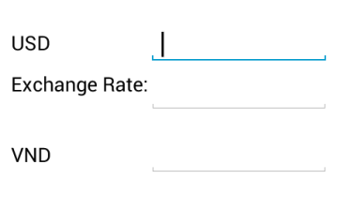
Drag a Button to it and name it as follow:
Control | ID | String | R.id.String
button1 | calc_button | Calculate | calc_button_string
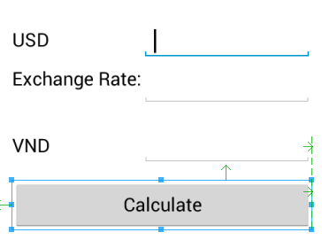
In On Click, set : calculate
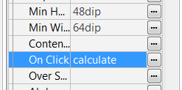
Press Ctrl +S to save all.

Write inner code
Go to MainActivity. Create function calculate as follow:
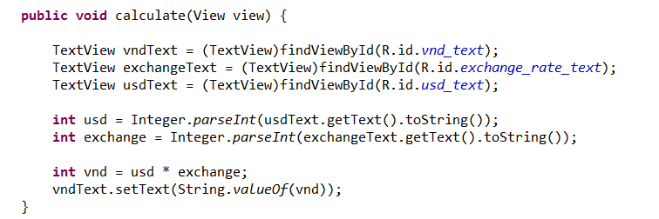
Press Ctrl + S to save all.

Run test
Run Android Virtual Machine Android4.2 on AVD Manager.
Right click on MyFirstGuiApp -> Run -> Android Application.
Switch to Android4.2 virtual machine.
Type 300 to USD, 21025 to Exchange Rate.
Press Calculate. The result must be like the screen follow:
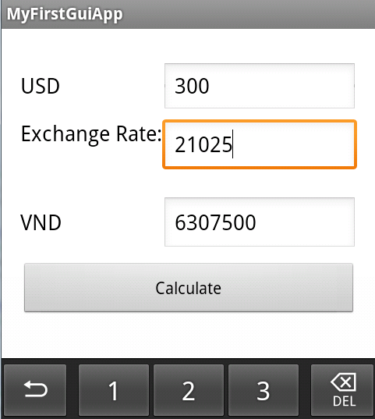

Congratulation! You have finished the third exercise.

Do It Yourself: Create an application with learned knowledges
Calculate the days from the day user was born until now.

GUI requirement
The application should have the GUI as follow:
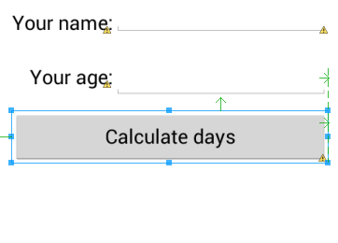

Logic requirement

Constraint:
Name should be 6-10 characters
Age should be 5-80
If it has any wrong, please show error warning to them.

Result
Should show number of days user have been alive.
